Pipeline

- An overview of pipelining
- Single-Cycle versus Pipelined Performance
- Pipeline Hazards
- Pipelined Datapath and Control.
- Datapath walkthrough
- Hazards solution

Textbook: P&H. Chapter 4.5.

An Overview of pipelining

Pipelining is an implementation technique in which multiple instructions are overlapped in execution. Today pipelining is nearly universal.

Anyone who has done a lot of laundry has intuitively used pipelining. The non-pipelined approach to laundry would be
1. Place one dirty load of clothes in the washer.
2. When the washer is finished, place the wet load in the dryer.
3. When the dryer is finished, place the dry load on a table and fold.
4. When folding is finished, ask your roommate to put the clothes away.
When your roommate is done, then start over with the next dirty load.

The pipelined approach takes much less time, as Figure 4.25 shows.
- As soon as the washer is finished with the first load and placed in the dryer, you load the washer with the second dirty load.
- When the first load is dry, you place it on the table to start folding, move the wet load to the dryer, and the next dirty load into the washer.
- Next you have your roommate put the first load away, you start folding the second load, the dryer has the third load, and you put the fourth load into the washer.
- At this point all steps—called stages in pipelining—are operating concurrently.

As long as we have separate resources for each stage, we can pipeline the tasks.

The pipelining paradox is that the time from placing a single dirty sock in the washer until it is dried, folded, and put away is not shorter for pipelining; the reason pipelining is faster for many loads is that everything is working in parallel, so more loads are finished per hour. Pipelining improves throughput of our laundry system.
Hence, pipelining would not decrease the time to complete one load of laundry, but when we have many loads of laundry to do, the improvement in throughput decreases the total time to complete the work.

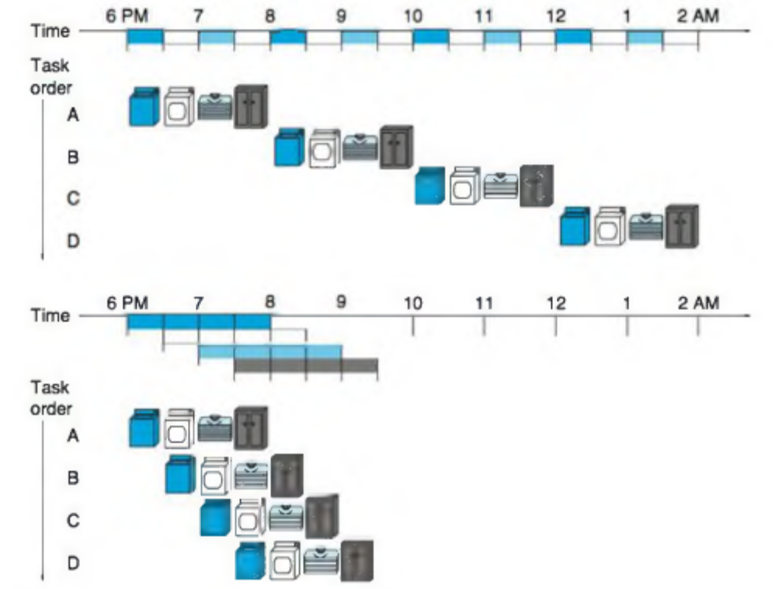

FIGURE 4.25 The laundry analogy for pipelining. Ann, Brian, Cathy, and Don each have dirty clothes to be washed, dried, folded, and put away. The washer, dryer, “folder,” and “storer” each take 30 minutes for their task. Sequential laundry takes 8 hours for 4 loads of wash, while pipelined laundry takes just 3.5 hours.
We show the pipeline stage of different loads over time by showing copies of the four resources on this two-dimensional time line, but we really have just one of each resource.

If all the stages take about the same amount of time and there is enough work to do, then the speed-up due to pipelining is equal to the number of stages in the pipeline, in this case four: washing, drying, folding, and putting away. Therefore, pipelined laundry is potentially four times faster than non-pipelined: 20 loads would take about 5 times as long as 1 load, while 20 loads of sequential laundry takes 20 times as long as 1 load. It’s only 2.3 times faster in Figure 4.25, because we only show 4 loads. Notice that at the beginning and end of the workload in the pipelined version in Figure 4.25, the pipeline is not completely full; this start-up and wind-down affects performance when the number of tasks is not large compared to the number of stages in the pipeline. If the number of loads is much larger than 4, then the stages will be full most of the time and the increase in throughput will be very close to 4.

The same principles apply to processors where we pipeline instruction execution.

MIPS instructions classically take 5 steps:

- Fetch instruction from memory. Increment PC
- Read registers while decoding the instruction. (the format of MIPS instruction allows reading and decoding to occur simultaneously).
- Execute the operation or calculate an address.
- Access an operand in data memory.
- Write the result into a register.

Hence, the MIPS pipeline we explore in this chapter has five stages. The following example shows that pipelining speeds up instruction execution just as it speeds up the laundry.

Single-Cycle versus Pipelined Performance

To make this discussion concrete, let’s create a pipeline. In this example, and in the rest of this chapter, we limit our attention to eight instructions: load word (lw),store word (sw), add (add), subtract (sub), AND (and), OR (or), set less than (slt), and branch on equal (beq).
Compare the average time between instructions of a single-cycle implementation, in which all instructions take one clock cycle, to a pipelined implementation.
The operation times for the major functional units in this example are 200 ps for memory access, 200 ps for ALU operation, and 100 ps for register file read or write. In the single-cycle model, every instruction takes exactly one clock cycle, so the clock cycle must be stretched to accommodate the slowest instruction.

Figure 4.26 shows the time required for each of the eight instructions. The single-cycle design must allow for the slowest instruction—in Figure 4.26 it is lw—so the time required for every instruction is 800 ps. Similarly to Figure 4.25, Figure 4.27 compares non pipelined and pipelined execution of three load word instructions. Thus, the time between the first and fourth instructions in the non pipelined design is 3 x 800 ps or 2400 ps.
All the pipeline stages take a single clock cycle, so the clock cycle must be long enough to accommodate the slowest operation. Just as the single-cycle design must take the worst-case clock cycle of 800 ps, even though some instructions can be as fast as 500 ps, the pipelined execution clock cycle must have the worst-case clock cycle of 200 ps, even though some stages take only 100 ps. Pipelining still offers a fourfold performance improvement: the time between the first and fourth instructions is 3 x 200 ps or 600 ps.

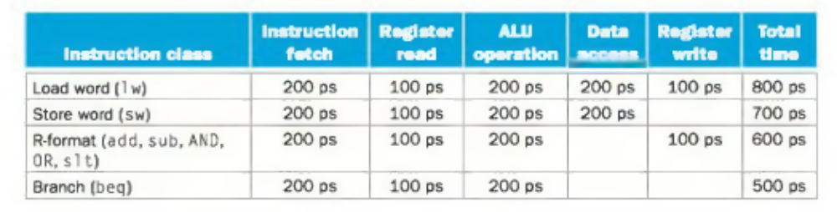

FIGURE 4.26 Total time for each instruction calculated from the time for each component.
This calculation assumes that the multiplexors, control unit, PC accesses, and sign extension unit have no delay.

We can turn the pipelining speed-up discussion above into a formula. If the
stages are perfecdy balanced, then the time between instructions on the pipelined
processor—assuming ideal conditions—is equal to

Under ideal conditions and with a large number of instructions, the speed-up from pipelining is approximately equal to the number of pipe stages; a five-stage pipeline is nearly five times faster.

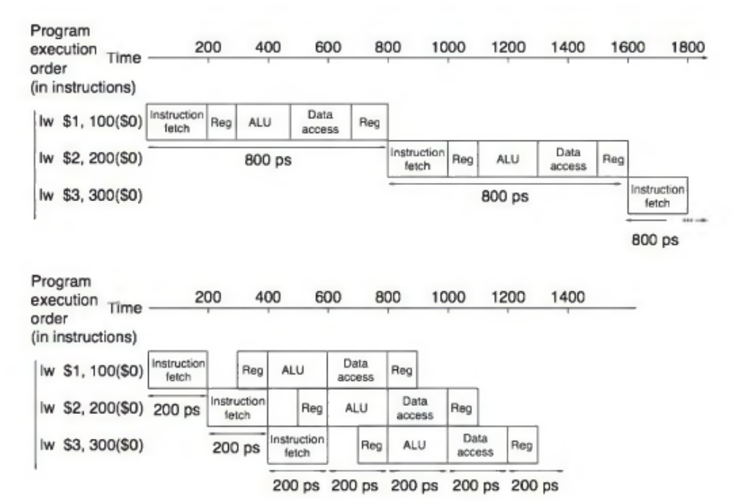

FIGURE 4.27 Single-cycle, nonpipelined execution in top versus pipelined execution in
bottom. Both use the same hardware components, whose time is listed in Figure 4.26. In this case, we see a fourfold speed-up on average time between instructions, from 800 ps down to 200 ps. Compare this figure to Figure 4.25. For the laundry, we assumed all stages were equal. If the dryer were slowest, then the dryer stage would set the stage time. The pipeline stage times of a computer are also limited by the slowest resource, either the ALU operation or the memory access. We assume the write to the register file occurs in the first half of the clock cycle and the read from the register file occurs in the second half. We use this assumption throughout this chapter.

Pipeline Hazards

There are situations in pipelining when the next instruction cannot execute in the following clock cycle. These events are called hazards, and there are three different types.

Structural Hazards
The first hazard is called a structural hazard. It means that the hardware cannot support the combination of instructions that we want to execute in the same clock cycle. A structural hazard in the laundry room would occur if we used a washer - dryer combination instead of a separate washer and dryer, or if our roommate was busy doing something else and wouldn’t put clothes away. Our carefully scheduled pipeline plans would then be foiled.

As we said above, the MIPS instruction set was designed to be pipelined, making it fairly easy for designers to avoid structural hazards when designing a pipeline. Suppose, however, that we had a single memory instead of two memories. If the pipeline in Figure 4.27 had a fourth instruction, we would see that in the same clock cycle the first instruction is accessing data from memory while the fourth instruction is fetching an instruction from that same memory. Without two memories, our pipeline could have a structural hazard.

Data Hazards
Data hazards occur when the pipeline must be stalled because one step must wait for another to complete. Suppose you found a sock at the folding station for which no match existed. One possible strategy is to run down to your room and search through your clothes bureau to see if you can find the match. Obviously, while you are doing the search, loads that have completed drying and are ready to fold and those that have finished washing and are ready to dry must wait.
In a computer pipeline, data hazards arise from the dependence of one instruction on an earlier one that is still in the pipeline (a relationship that does not really exist when doing laundry). For example, suppose we have an add instruction followed immediately by a subtract instruction that uses the sum ($s 0):
add $s0, $ t 0 , $11
sub $ t 2 , $s0, $t3

Without intervention, a data hazard could severely stall the pipeline. The add instruction doesn’t write its result until the fifth stage, meaning that we would have to waste three clock cycles in the pipeline.
Although we could try to rely on compilers to remove all such hazards, the results would not be satisfactory. These dependences happen just too often and the delay is just too long to expect the compiler to rescue us from this dilemma. The primary solution is based on the observation that we don’t need to wait for the instruction to complete before trying to resolve the data hazard. For the code sequence above, as soon as the ALU creates the sum for the add, we can supply it as an input for the subtract. Adding extra hardware to retrieve the missing item early from the internal resources is called forwarding or bypassing.

Forwarding Also called bypassing. A method of resolving a data hazard by retrieving the missing data element from internal buffers rather than waiting for it to arrive from programmer visible registers or memory.

Figure 4.29 shows the connection to forward the value in $ s 0 after the execution stage of the add instruction as input to the execution stage of the sub instruction.

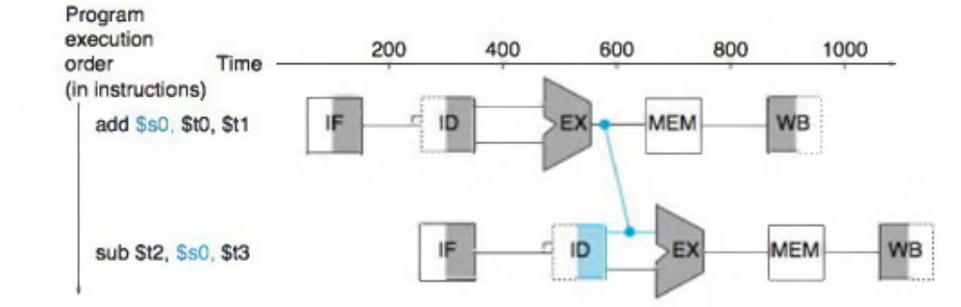

FIGURE 4.29 Graphical representation Of forwarding. The connection shows the forwarding path from the output of the EX stage of a d d to the input of the EX stage for sub, replacing the value from register $S0 read in the second stage of Sub.

In this graphical representation of events, forwarding paths are valid only if the destination stage is later in time than the source stage. For example, there cannot be a valid forwarding path from the output of the memory access stage in the first instruction to the input of the execution stage of the following, since that would mean going backward in time.
Forwarding works very well and is described in detail in Section 4.7. It cannot prevent all pipeline stalls, however. For example, suppose the first instruction was a load of $ s 0 instead of an add. As we can imagine from looking at Figure 4.29, the desired data would be available only after the fourth stage of the first instruction in the dependence, which is too late for the input of the third stage of sub. Hence, even with forwarding, we would have to stall one stage for a load-use data hazard, as Figure 4.30 shows. This figure shows an important pipeline concept, officially called a pipeline stall, but often given the nickname bubble. We shall see stalls elsewhere in the pipeline. Section 4.7 shows how we can handle hard cases like these, using either hardware detection and stalls or software that reorders code to try to avoid load-use pipeline stalls, as this example illustrates.

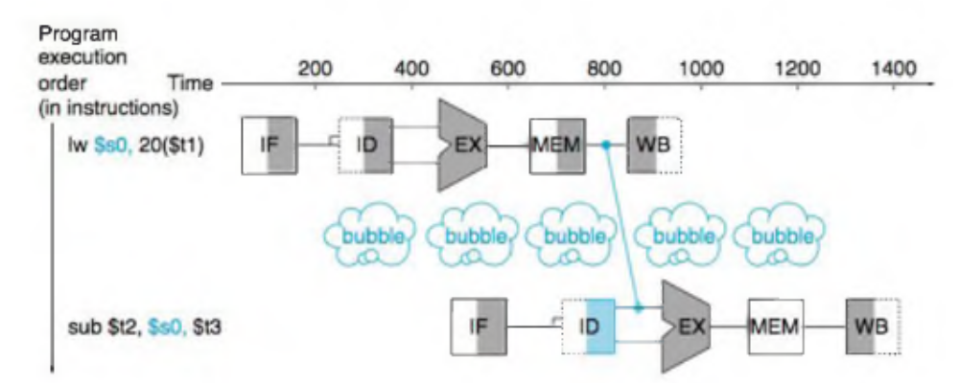

FIGURE 4.30 We need a stall even with forwarding when an R-format Instruction following a load tries to use the data, without the stall, the path from memory access stage output to execution stage input would be going backward in time, which is impossible.

Control Hazards
The third type of hazard is called a control hazard, arising from the need to make a decision based on the results of one instruction while others are executing.

The equivalent decision task in a computer is the branch instruction. Notice that we must begin fetching the instruction following the branch on the very next clock cycle. Nevertheless, the pipeline cannot possibly know what the next instruction should be, since it only just received the branch instruction from memory! Just as with laundry, one possible solution is to stall immediately after we fetch a branch, waiting until the pipeline determines the outcome of the branch and knows what
instruction address to fetch from.
Let’s assume that we put in enough extra hardware so that we can test registers, calculate the branch address, and update the PC during the second stage of the pipeline (see Section 4.8 for details). Even with this extra hardware, the pipeline involving conditional branches would look like Figure 4.31.

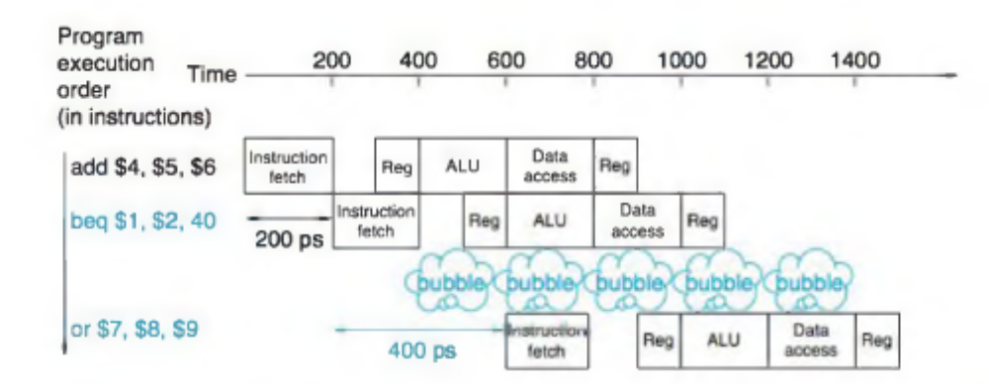

FIGURE 4.31 Pipeline showing stalling on every conditional branch as solution to control hazards. This example assumes the conditional branch is taken, and the instruction at the destination of the branch is the 0 R instruction. There is a one-stage pipeline stall, or bubble, after the branch

Pipelined Datapath and Control

Figure 4.33 shows the single-cycle datapath from Section 4.4 with the pipeline stages identified. The division of an instruction into five stages means a five-stage pipeline, which in turn means that up to five instructions will be in execution during any single clock cycle. Thus, we must separate the datapath into five pieces, with each piece named corresponding to a stage of instruction execution:

1. IF: Instruction fetch
2. ID: Instruction decode and register file read
3. EX: Execution or address calculation
4. MEM: Data memory access
5. WB: Writeback

In Figure 4.33, these five components correspond roughly to the way the datapath is drawn; instructions and data move generally from left to right through the five stages as they complete execution. Returning to our laundry analogy, clothes get cleaner, drier, and more organized as they move through the line, and they never move backward.

There are, however, two exceptions to this left-to-right flow of instructions:
■ The write-back stage, which places the result back into the register file in the middle of the datapath
■ The selection of the next value of the PC, choosing between the incremented
PC and the branch address from the MEM stage

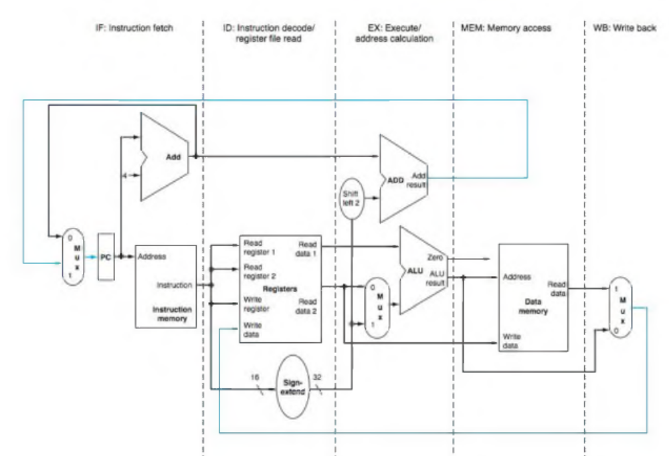

Data flowing from right to left does not affect the current instruction; only later instructions in the pipeline are influenced by these reverse data movements. Note that the first right-to-left flow of data can lead to data hazards and the second leads to control hazards.

One way to show what happens in pipelined execution is to pretend that each instruction has its own datapath, and then to place these datapaths on a timeline to show their relationship. Figure 4.34 shows the execution of the instructions in Figure 4.27 by displaying their private datapaths on a common timeline. We
use a stylized version of the datapath in Figure 4.33 to show the relationships in Figure 4.34.

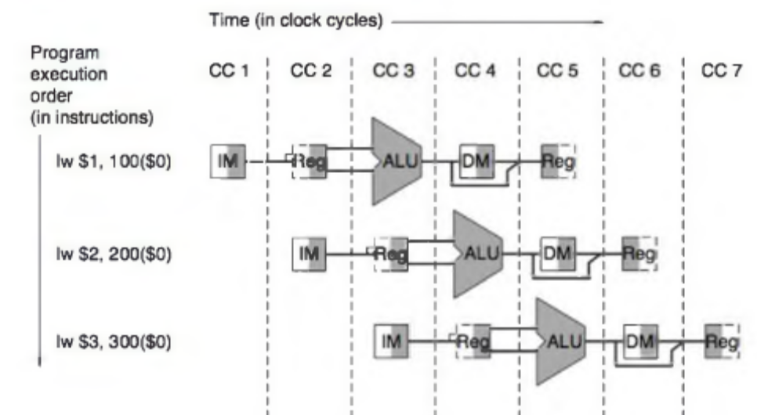
FIGURE 4.34 Instructions being executed using the single-cycle datapath in Figure 4.33, assuming pipelined execution. Similar to Figures 4.28 through 4.30, this figure pretends that each instruction has its own datapath, and shades each portion according to use. Unlike those figures, each stage is labeled by the physical resource used in that stage, corresponding to the portions of the datapath in Figure 4.33. IM represents the instruction memory and the PC in the instruction fetch stage, Reg stands for the register file and sign extender in the instruction decode/register file read stage (ID), and so on. To maintain proper time order, this stylized datapath breaks the register file into two logical parts: registers read during register fetch (ID) and registers written during write back (WB). This dual use is represented by drawing the unshaded left half of the register file using dashed lines in the ID stage, when it is not being written, and the unshaded right half in dashed lines in the WB stage, when it is not being read. As before, we assume the register file is written in the first half of the clock cycle and the register file is read during the second half.

Figure 4.34 seems to suggest that three instructions need three datapaths.
Instead, we add registers to hold data so that portions of a single datapath can be shared during instruction execution.

For example, as Figure 4.34 shows, the instruction memory is used during only one of the five stages of an instruction, allowing it to be shared by following instructions during the other four stages. To retain the value of an individual instruction for its other four stages, the value read from instruction memory must be saved in a register. Similar arguments apply to every pipeline stage, so we must place registers wherever there are dividing lines between stages in Figure 4.33. Returning to our laundry analogy, we might have a basket between each pair of stages to hold the clothes for the next step.

Figure 4.35 shows the pipelined datapath with the pipeline registers highlighted. All instructions advance during each clock cycle from one pipeline register to the next. The registers are named for the two stages separated by that register. For example, the pipeline register between the IF and ID stages is called IF/ID.

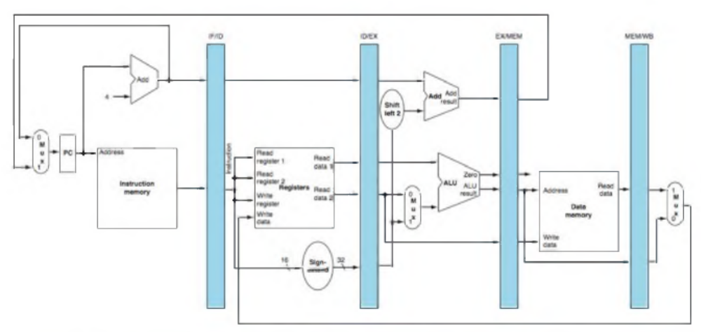

FIGURE 4.35 The pipelined version Of the datapath In Figure 4.33. The pipeline registers, in color, separate each pipeline stage.
They are labeled by the stages that they separate; for example, the first is labeled IF/ID because it separates the instruction fetch and instruction
decode stages. The registers must be wide enough to store all the data corresponding to the lines that go through them. For example, the IF/ID
register must be 64 bits wide, because it must hold both the 32-bit instruction fetched from memory and the incremented 32-bit PC address.
We will expand these registers over the course of this chapter, but for now the other three pipeline registers contain 128, 97, and 64 bits,
respectively.

Notice that there is no pipeline register at the end of the write-back stage. All instructions must update some state in the processor—the register file, memory, or the PC—so a separate pipeline register is redundant to the state that is updated. For example, a load instruction will place its result in 1 of the 32 registers, and any
later instruction that needs that data will simply read the appropriate register.

Figures 4.36 through 4.38, our first sequence, show the active portions of the datapath highlighted as a load instruction goes through the five stages of pipelined execution. We show a load first because it is active in all five stages. As in Figures 4.28 through 4.30, we highlight the right half of registers or memory when they are being read and highlight the left half when they are being written.

We show the instruction abbreviation 1 w with the name of the pipe stage that is active in each figure. The five stages are the following:

- Instruction fetch: The top portion of Figure 4.36 shows the instruction being read from memory using the address in the PC and then being placed in the IF/ID pipeline register. The PC address is incremented by 4 and then written back into the PC to be ready for the next clock cycle. This incremented address is also saved in the IF/ID pipeline register in case it is needed later for an instruction, such as beq. The computer cannot know which type of instruction is being fetched, so it must prepare for any instruction, passing potentially needed information down the pipeline.

- Instruction decode and register file read: The bottom portion of Figure 4.36 shows the instruction portion of the IF/ID pipeline register supplying the 16-bit immediate field, which is sign-extended to 32 bits, and the register numbers to read the two registers. All three values are stored in the ID/EX pipeline register, along with the incremented PC address. We again transfer everything that might be needed by any instruction during a later clock cycle.

- Execute or address calculation: Figure 4.37 shows that the load instruction reads the contents of register 1 and the sign-extended immediate from the ID/EX pipeline register and adds them using the ALU. That sum is placed in the EX/MEM pipeline register.

- Memory access: The top portion of Figure 4.38 shows the load instruction reading the data memory using the address from the EX/MEM pipeline register and loading the data into the MEM/WB pipeline register.

- Write-back: The bottom portion of Figure 4.38 shows the final step: reading the data from the MEM/WB pipeline register and writing it into the register file in the middle of the figure.

Walkthrough

This walk-through of the load instruction shows that any information needed in a later pipe stage must be passed to that stage via a pipeline register.

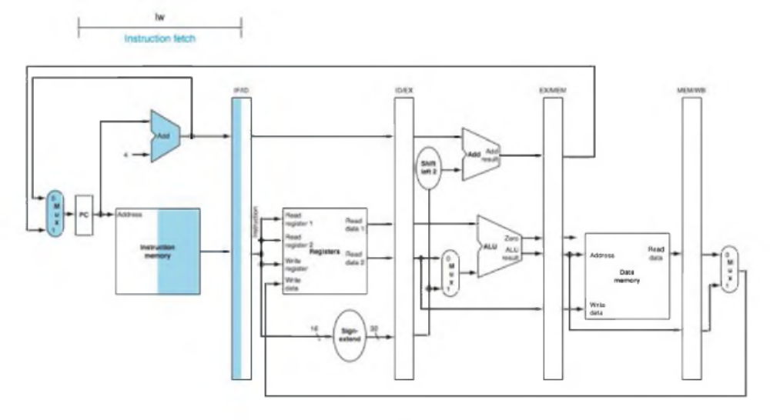

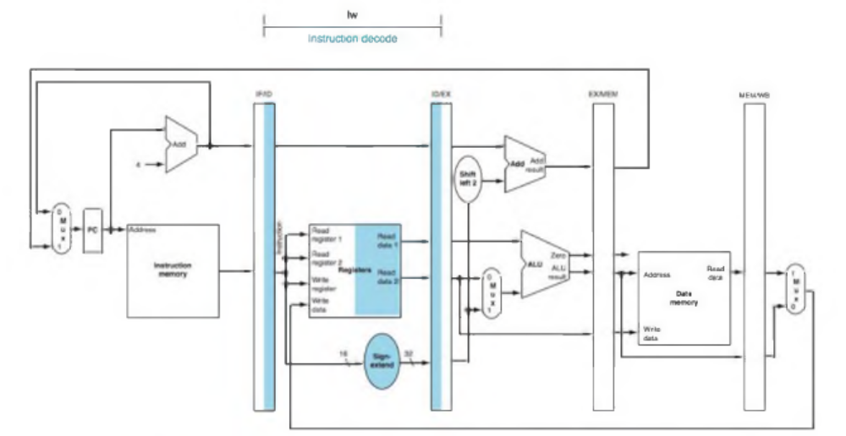

FIGURE 4.36 IF and ID: First and second pipe stages of an instruction, with the active portions of the datapath in
Figure 4.35 highlighted. The highlighting convention is the same as that used in Figure 4.28. As in Section 4.2, there is no confusion when
reading and writing registers, because the contents change only on the clock edge. Although the load needs only the top register in stage 2,
the processor doesn’t know what instruction is being decoded, so it sign-extends the 16-bit constant and reads both registers into the ID/EX
pipeline register. We don’t need all three operands, but it simplifies control to keep all three.

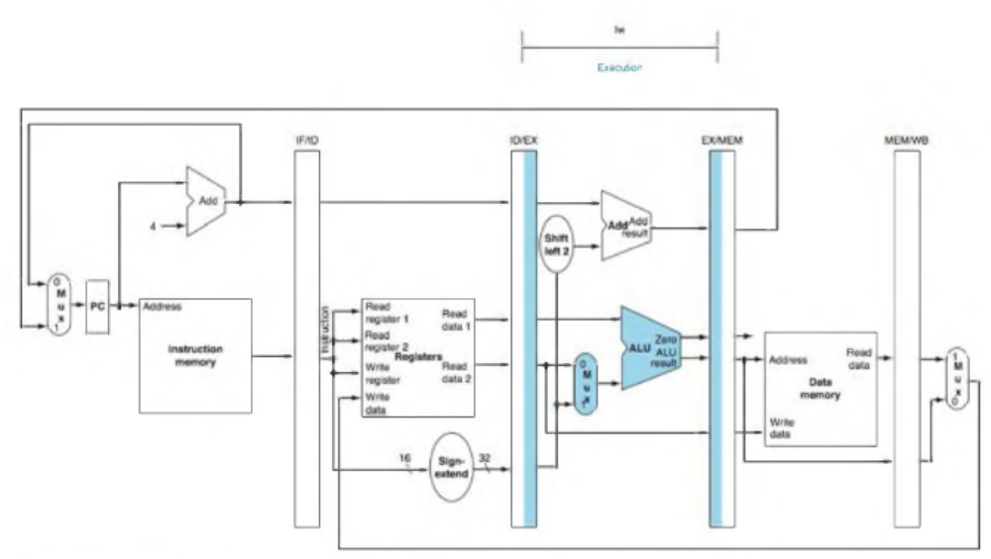

FIGURE 4.37 EX: The third pipe stage of a load Instruction, highlighting the portions of the datapath in Figure 4.35
used in this pipe stage. The register is added to the sign-extended immediate, and the sum is placed in the EX/MEM pipeline register.

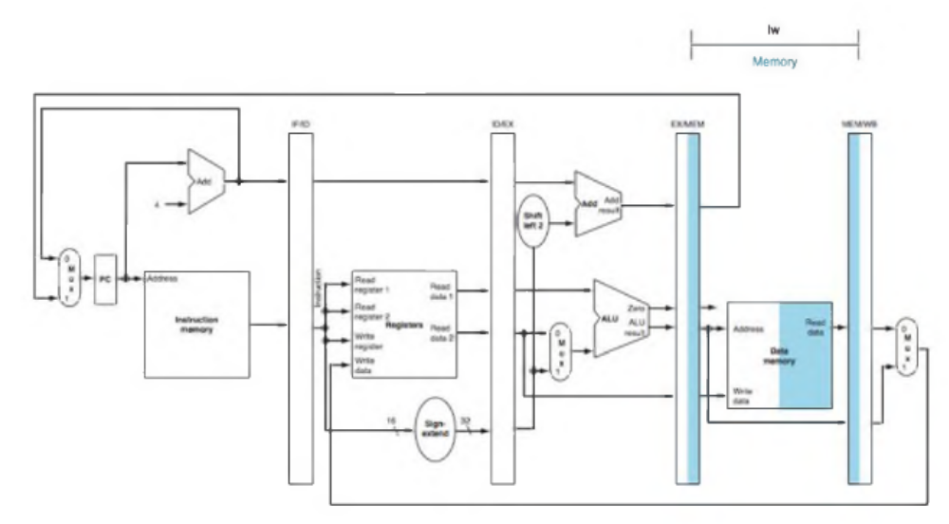

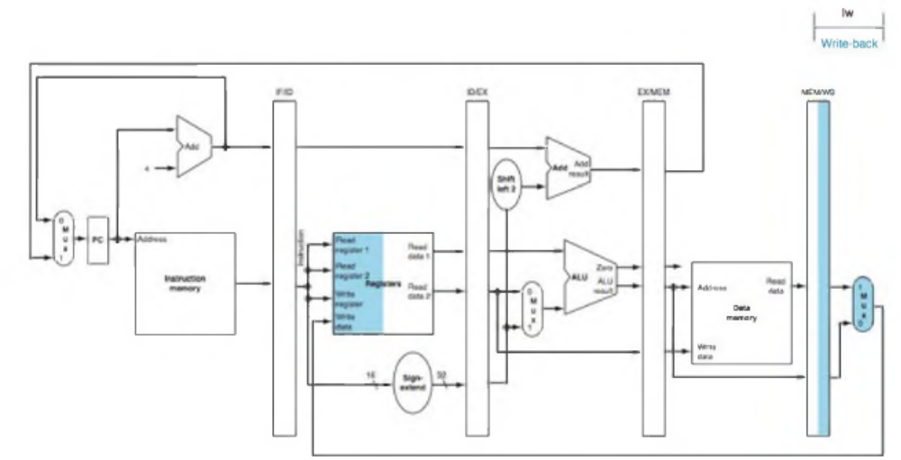

HGURE 4.38 MEM and WB: The fourth and fifth pipe stages of a load instruction, highlighting the portions of the
datapath in Figure 4.35 used in this pipe Stage. Data memory is read using the address in the EX/MEM pipeline registers, and the
data is placed in the MEM/WB pipeline register. Next, data is read from the MEM/WB pipeline register and written into the register file in the
middle o f the datapath. Note: there is a bug in this design that is repaired in Figure 4.41.

Walking through a store instruction shows the similarity of instruction execution, as well as passing the information for later stages. Here are the five pipe stages of the store instruction:

- Instruction fetch: The instruction is read from memory using the address in the PC and then is placed in the IF/ID pipeline register. This stage occurs before the instruction is identified, so the top portion of Figure 4.36 works for store as well as load.
- Instruction decode and register file read: The instruction in the IF/ID pipeline register supplies the register numbers for reading two registers and extends the sign of the 16-bit immediate. These three 32-bit values are all stored in the ID/EX pipeline register. The bottom portion of Figure 4.36 for load instructions also shows the operations of the second stage for stores. These first two stages are executed by all instructions, since it is too early to know the type of the instruction.
- Execute and address calculation: Figure 4.39 shows the third step; the effective address is placed in the EX/MEM pipeline register.
- Memory access: The top portion of Figure 4.40 shows the data being written to memory. Note that the register containing the data to be stored was read in an earlier stage and stored in ID/EX. The only way to make the data available during the MEM stage is to place the data into the EX/MEM pipeline register in the EX stage, just as we stored the effective address into EX/MEM.
- Write-back: The bottom portion of Figure 4.40 shows the final step of the store. For this instruction, nothing happens in the write-back stage. Since every instruction behind the store is already in progress, we have no way to accelerate those instructions. Hence, an instruction passes through a stage even if there is nothing to do, because later instructions are already progressing at the maximum rate.

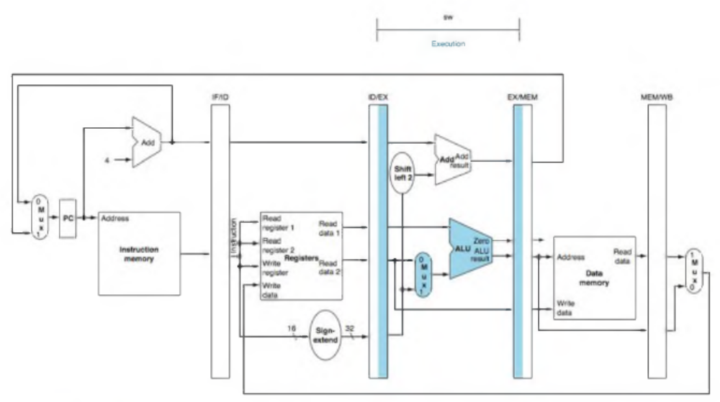
FIGURE 4.39 EX: The third pipe stage Of a Store Instruction. Unlike the third stage of the load instruction in Figure 4.37, the
second register value is loaded into the EX/MEM pipeline register to be used in the next stage. Although it wouldn’t hurt to always write this
second register into the EX/MEM pipeline register, we write the second register only on a store instruction to make the pipeline easier to
understand.

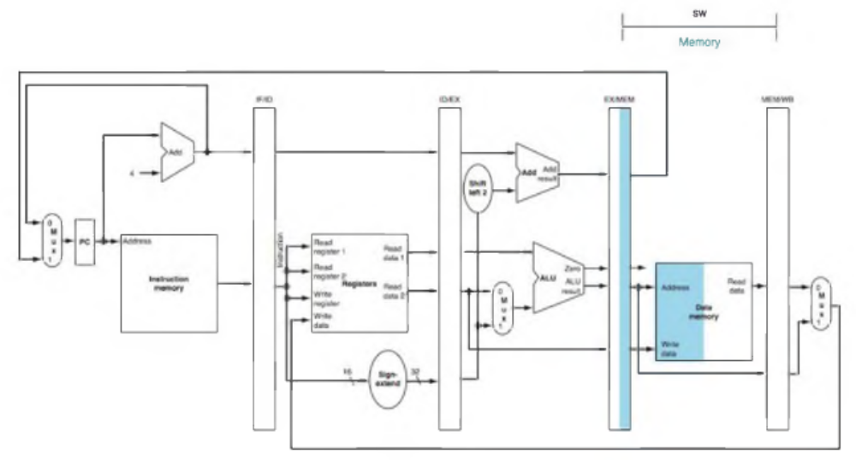
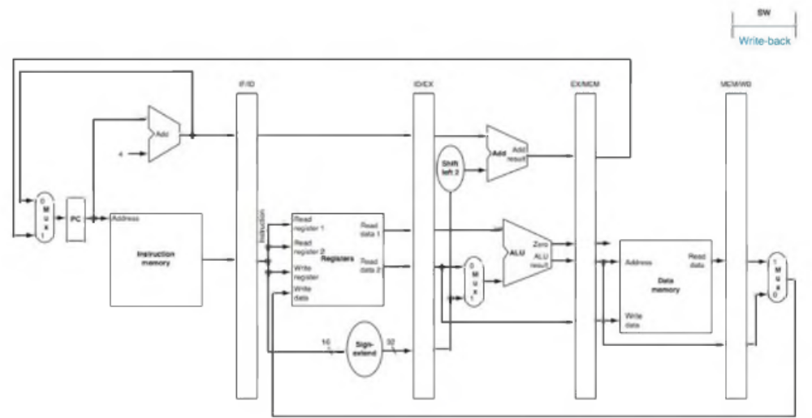

FIGURE 4.40 MEM and WB: The fourth and fifth pipe stages Of a store instruction. In the fourth stage, the data is written into
data memory for the store. Note that the data comes from the EX/MEM pipeline register and that nothing is changed in the MEM/WB pipeline
register. Once the data is written in memory, there is nothing left for the store instruction to do, so nothing happens in stage 5.

The store instruction again illustrates that to pass something from an early pipe stage to a later pipe stage, the information must be placed in a pipeline register; otherwise, the information is lost when the next instruction enters that pipeline stage. For the store instruction we needed to pass one of the registers read in the ID stage to the MEM stage, where it is stored in memory. The data was first placed in the ID/EX pipeline register and then passed to the EX/MEM pipeline register.

Load and store illustrate a second key point; each logical component of the datapath—such as instruction memory, register read ports, ALU, data memory, and register write port—can be used only within a single pipeline stage. Otherwise, we would have a structural hazard (see page 335). Hence these components, and their control, can be associated with a single pipeline stage.

Now we can uncover a bug in the design of the load instruction. Did you see it? Which register is changed in the final stage of the load? More specifically, which instruction supplies the write register number? The instruction in the IF/ID pipeline register supplies the write register number, yet this instruction occurs considerably after the load instruction!

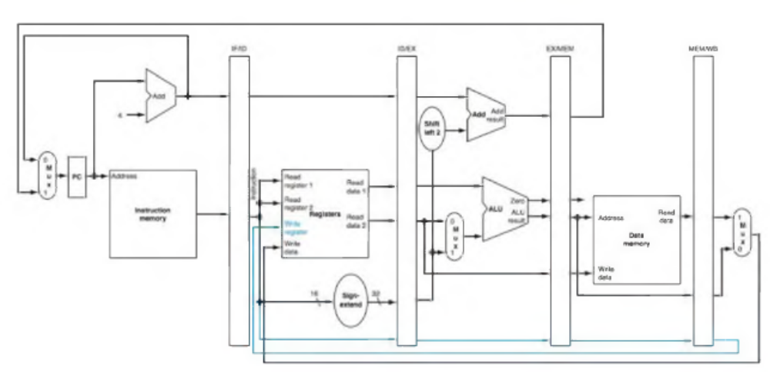
FIGURE 4.41 The corrected pipelined datapath to handle the load instruction properly. The write register number now
comes from the MEM/WB pipeline register along with the data. The register number is passed from the ID pipe stage until it reaches the
MEM/WB pipeline register, adding five more bits to the last three pipeline registers. This new path is shown in color.

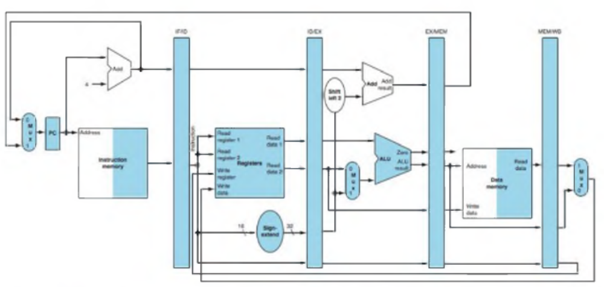
FIGURE 4.42 The portion of the datapath In Figure 4.41 that Is used in all five stages of a load instruction.

Hazards Solution

Structural Hazards are Conflicts for use of a resource
- In MIPS pipeline with a single memory
  - Load/Store requires memory access for data
  - Instruction fetch would have to stall for that cycle
    - Causes a pipeline “bubble”
- Hence, pipelined datapaths require separate instruction/data memories

In reality there is provided separate L1 cache for Instructions and L1 cache for data. Then there are 2 different memories which could be used separately and do not cause hazard.
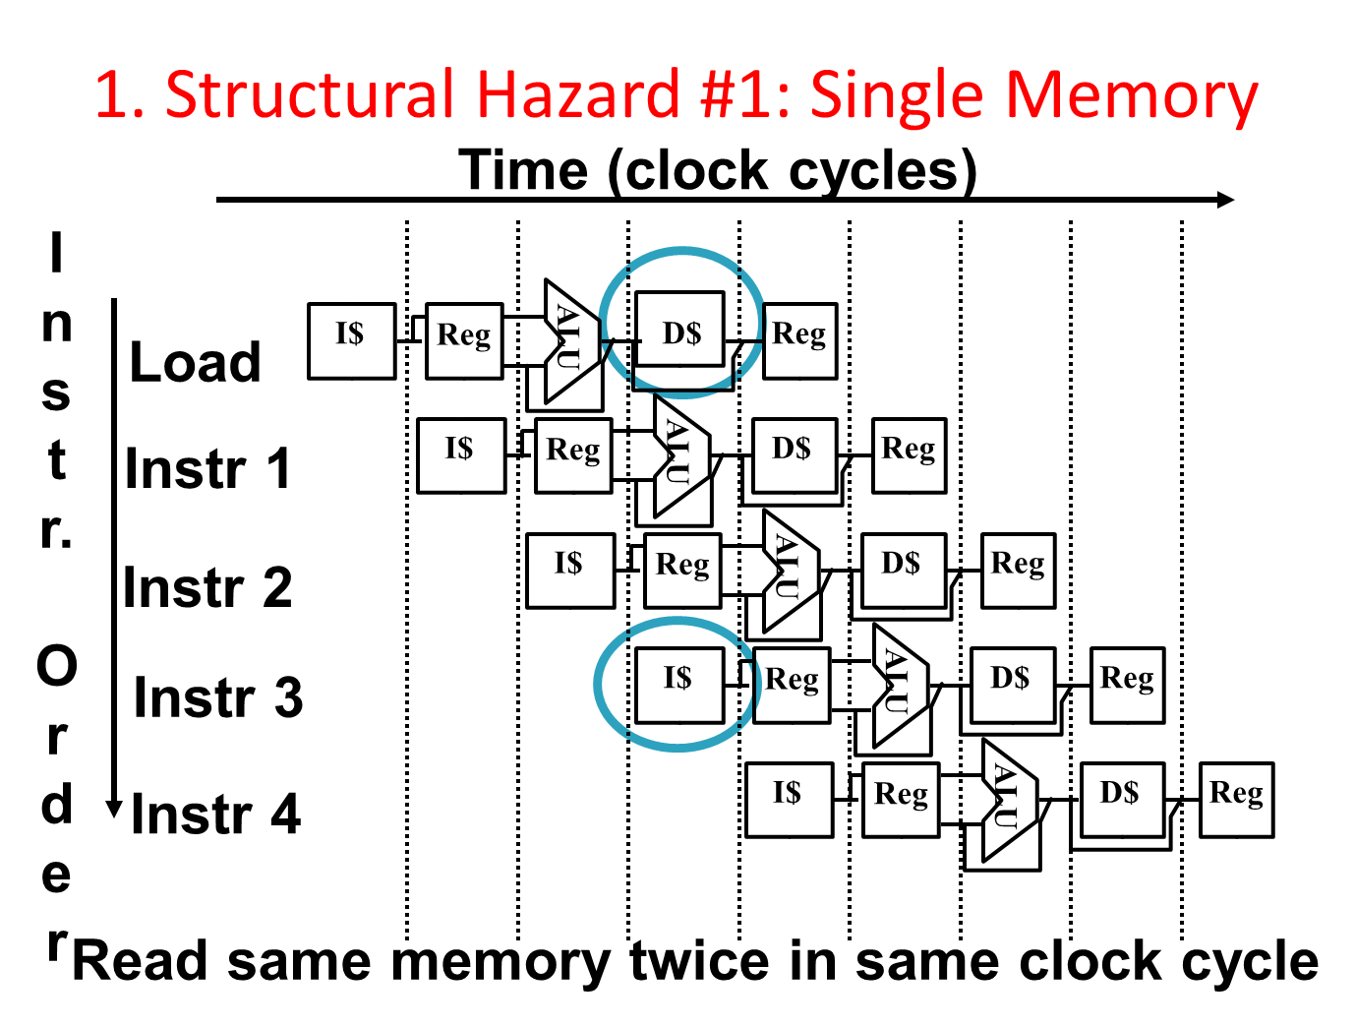
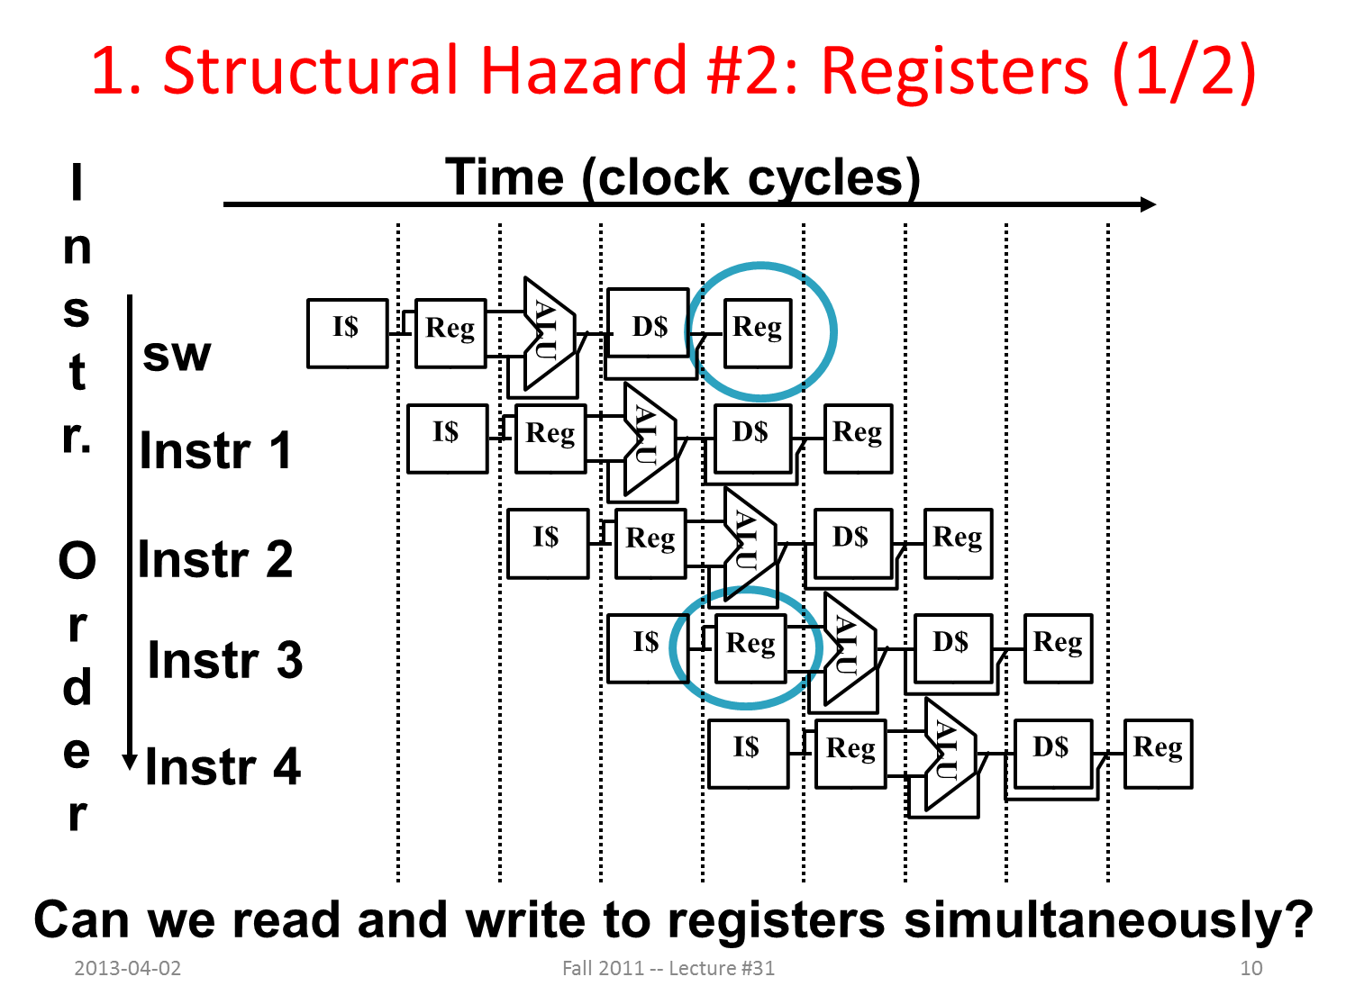

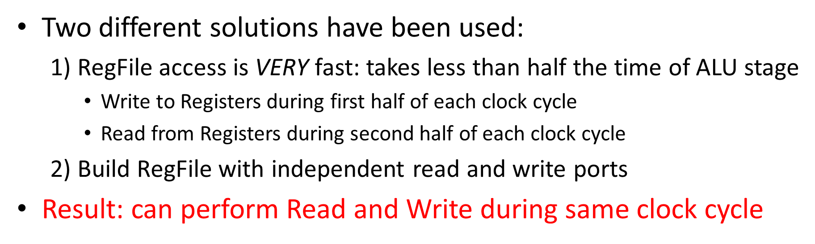

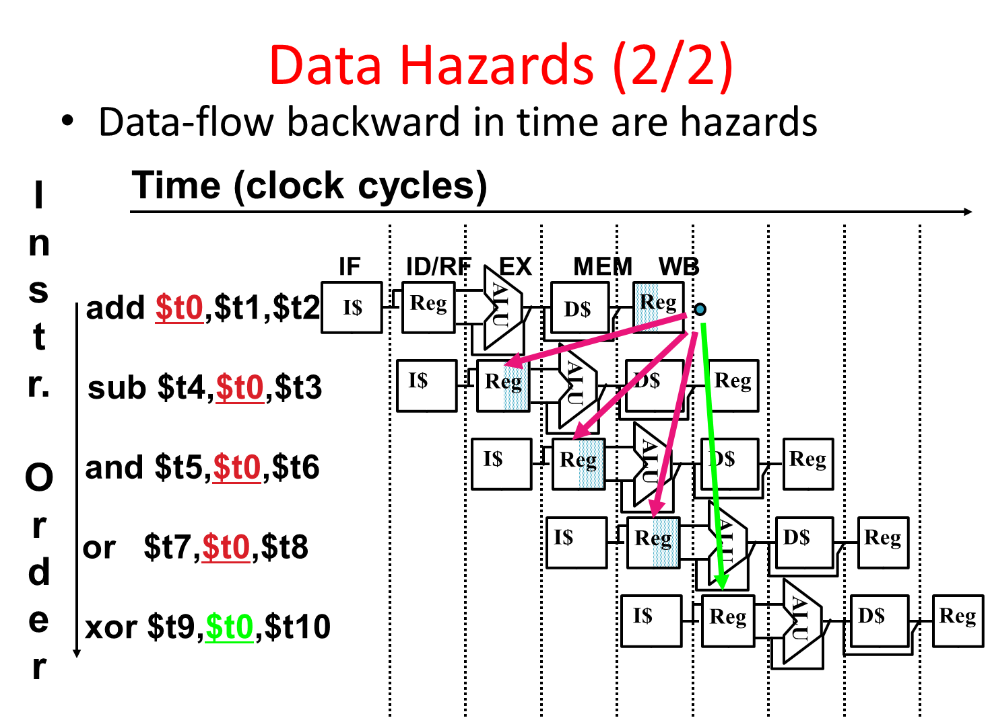
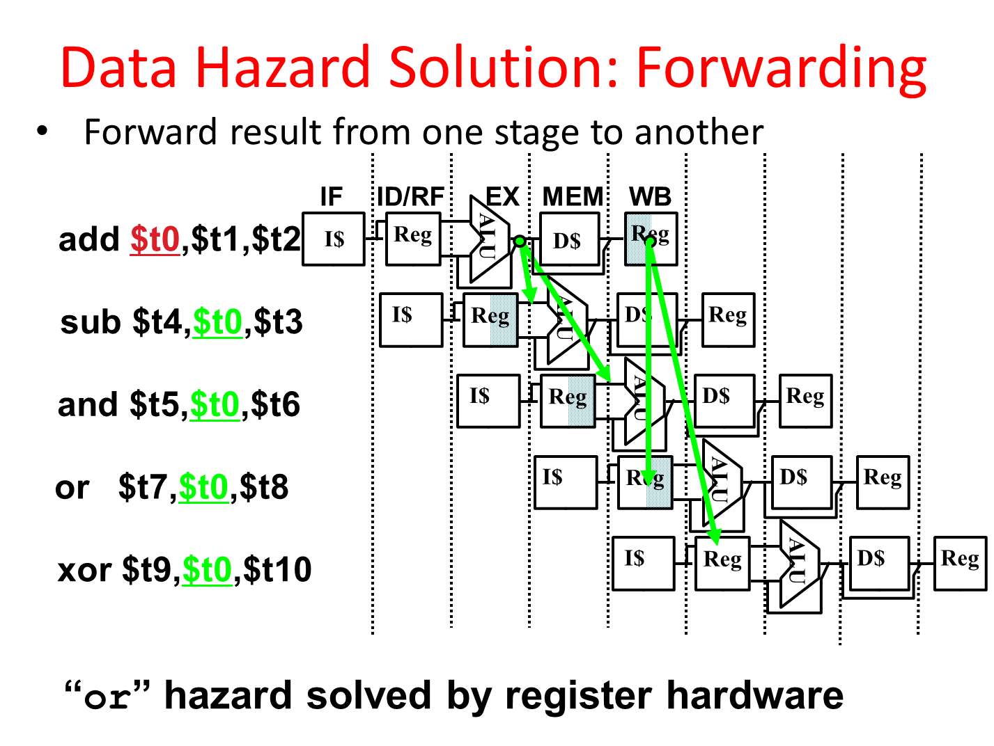

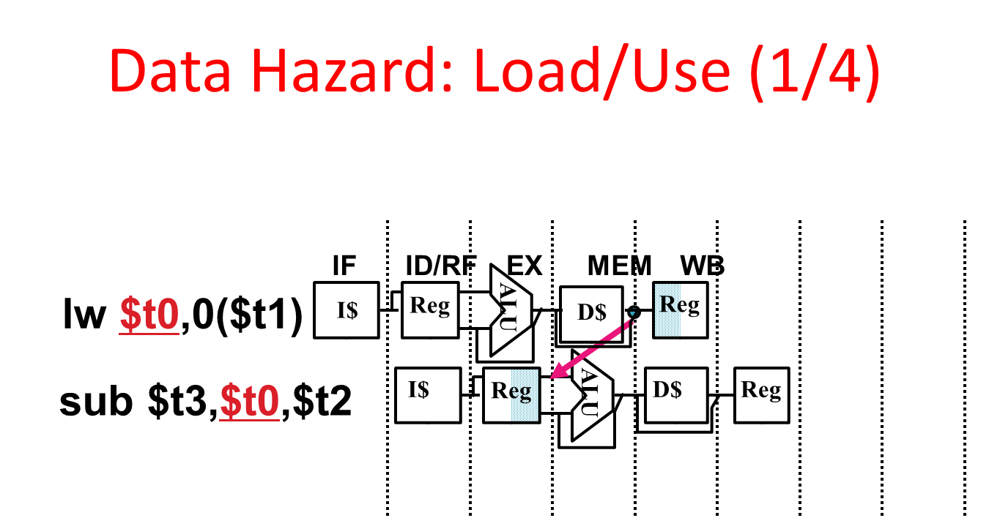

- Can’t solve all cases with forwarding
- Must stall instruction dependent on load, then forward (needs more hardware)
- Instruction slot after a load is called “load delay slot”
- If that instruction uses the result of the load, then the hardware interlock will stall it for one cycle.
- Alternative: If the compiler puts an unrelated instruction in that slot, then no stall
- Letting the hardware stall the instruction in the delay slot is equivalent to putting a nop in the slot (except the latter uses more code space)
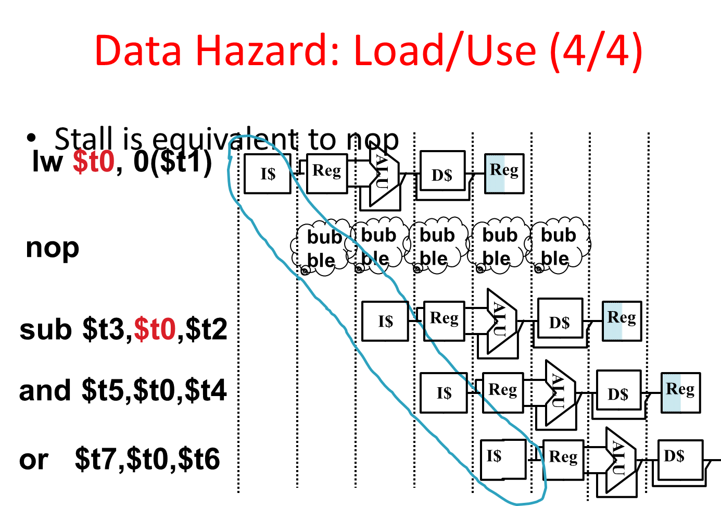

3. Control Hazards

- Branch determines flow of control
  - Fetching next instruction depends on branch outcome
  - Pipeline can’t always fetch correct instruction
    - Still working on ID stage of branch
- BEQ, BNE in MIPS pipeline
- Simple solution Option 1: Stall on every branch until have new PC value
Would add 2 bubbles/clock cycles for every
  - Branch! (~ 20% of instructions executed)
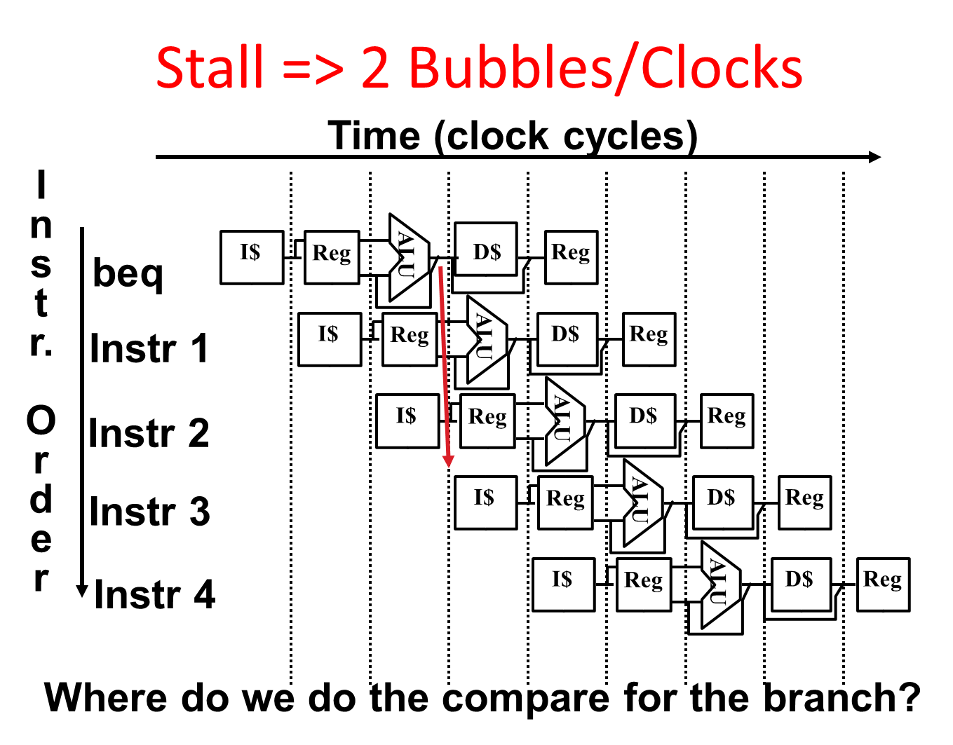

- Optimization #1:
  - Insert special branch comparator in Stage 2
  - As soon as instruction is decoded (Opcode identifies it as a branch), immediately make a decision and set the new value of the PC
  - Benefit: since branch is complete in Stage 2, only one unnecessary instruction is fetched, so only one no-op is needed
  - Side Note: means that branches are idle in Stages 3, 4 and 5

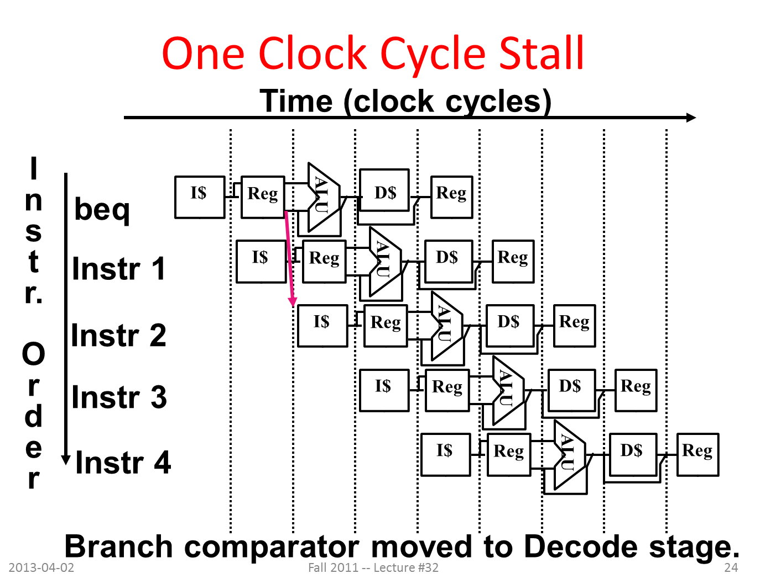

- Option 2: Predict outcome of a branch, fix up if guess wrong
  - Must cancel all instructions in pipeline that depended on guess that was wrong
  - This is called “flushing” the pipeline
- Simplest hardware if we predict that all branches are NOT taken

- Option #3: Redefine branches
  - Old definition: if we take the branch, none of the instructions after the branch get executed by accident
  - New definition: whether or not we take the branch, the single instruction immediately following the branch gets executed (the branch-delay slot)
- Delayed Branch means we always execute inst after branch
- This optimization is used with MIPS

